Section 9.6.1

Syllabus | Questions
- gather secondary information to observe at least two ultrasound images of body organs (C3)  - identify data sources and gather information to observe the flow of blood through the heart from a Doppler ultrasound video image (C3) | - Present two images (one of which must be a Doppler ultrasound image) and outline the medical significance of the images.
- identify the differences between ultrasound and sound in normal hearing range | - Identify the differences between ultrasound and sound in normal hearing range.  - Outline one advantage that the use of 8 MHz ultrasound would have over 2 MHz ultrasound in producing an image of a baby’s bones.
- describe the piezoelectric effect and the effect of using an alternating potential difference with a piezoelectric crystal | - Describe the piezoelectric effect.  - Identify a material, used in medical imaging, that has piezoelectric properties.  - Explain the reason why an alternating potential difference is used to produce ultrasound.
- define acoustic impedance:    and identify that different materials have different acoustic impedances | - Define acoustic impedance.  - Identify the symbol for and SI units of density.
 | - Account for the fact that different materials have different acoustic impedances.
- solve problems and analyse information using (C3)  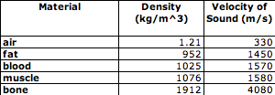 | - Calculate the acoustic impedance of fat which has a density of 952 kg m⁻³ and in which the speed of sound is 1450 m s⁻¹.  - The speed of sound in kidney tissue (1560 m s⁻¹) is greater than its speed in liver (1550 m s⁻¹) and yet the acoustic impedance of kidney is less than that of liver. What deduction can be made from these facts?
- solve problems and analyse information to calculate the acoustic impedance of a range of materials, including bone, muscle, soft tissue, fat, blood and air and explain the types of tissues that ultrasound can be used to examine (C3) | - Use the data in the table to compare the acoustic impedances of air, blood, fat and bone.
- describe how the principles of acoustic impedance and reflection and refraction are applied to ultrasound | - Describe the role of acoustic impedance in the ultrasound imaging.  - Outline how an ultrasound image is produced.  - Explain the relevance of reflection and refraction to the production of an ultrasound image.
- define the ratio of reflected to initial intensity as:  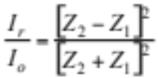 | - Outline the factors that determine the ratio of the reflected intensity of an ultrasound wave in the body to the incident wave.  - Calculate the percentage of ultrasound reflected at a muscle – bone boundary in the body (the acoustic impedance of muscle is 1.7 megarayls and that of bone is 7.8 megarayls.
- solve problems and analyse information using  (C3) | - Compare the proportion of the ultrasound signal reflected at a muscle - fat boundary with the proportion reflected at a muscle - bone boundary.
- identify that the greater the difference in acoustic impedance between two materials, the greater is the reflected proportion of the incident pulse | - Identify the effect on the proportion of reflected ultrasound of the acoustic impedance of tissues at the reflecting boundary.
- describe the situations in which A scans, B scans, and phase and sector scans would be used and the reasons for the use of each | - Outline how an ultrasound A scan is produced.  - Identify a situation in which an ultrasound A scan would be made.  - Outline how an ultrasound B scan is produced.  - Identify a situation in which an ultrasound B scan would be made.  - Outline how a sector scan is produced.  - Identify a situation in which a sector scan would be useful.  - Outline how an ultrasound phase scan is produced.  - Identify a situation in which a phase scan would be useful.
- identify data sources, gather, process and analyse information to describe how ultrasound is used to measure bone density (C3) | - Describe how ultrasound is used to measure bone density.  - Identify the part of the body used to determine bone density using ultrasound.
- describe the Doppler effect in sound waves and how it is used in ultrasonics to obtain flow characteristics of blood moving through the heart  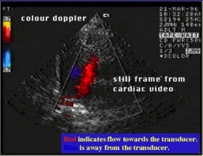 | - Describe how the Doppler effect is produced using sound waves.  - Identify the characteristic of blood flow that can be studied using Doppler ultrasound.  - Describe the type of information that can be obtained from the ultrasound scan in the adjacent image.  - Explain how the Doppler effect can be used to obtain information about the flow of blood through the heart.
- outline some cardiac problems that can be detected through the use of the Doppler effect | - Outline some cardiac problems that can be detected through the use of the Doppler effect.

Section 9.6.2

2. The physical properties of electromagnetic radiation can be used as diagnostic tools
- gather information to observe at least one image of a fracture on an X-ray film and X-ray images of other body parts (C3)  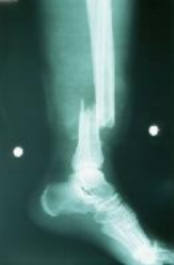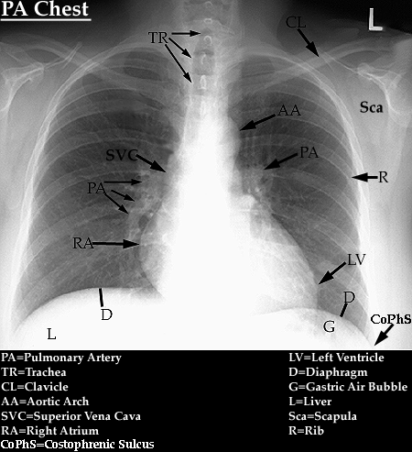 | - Outline the usefulness of X-ray imaging evident from the image below  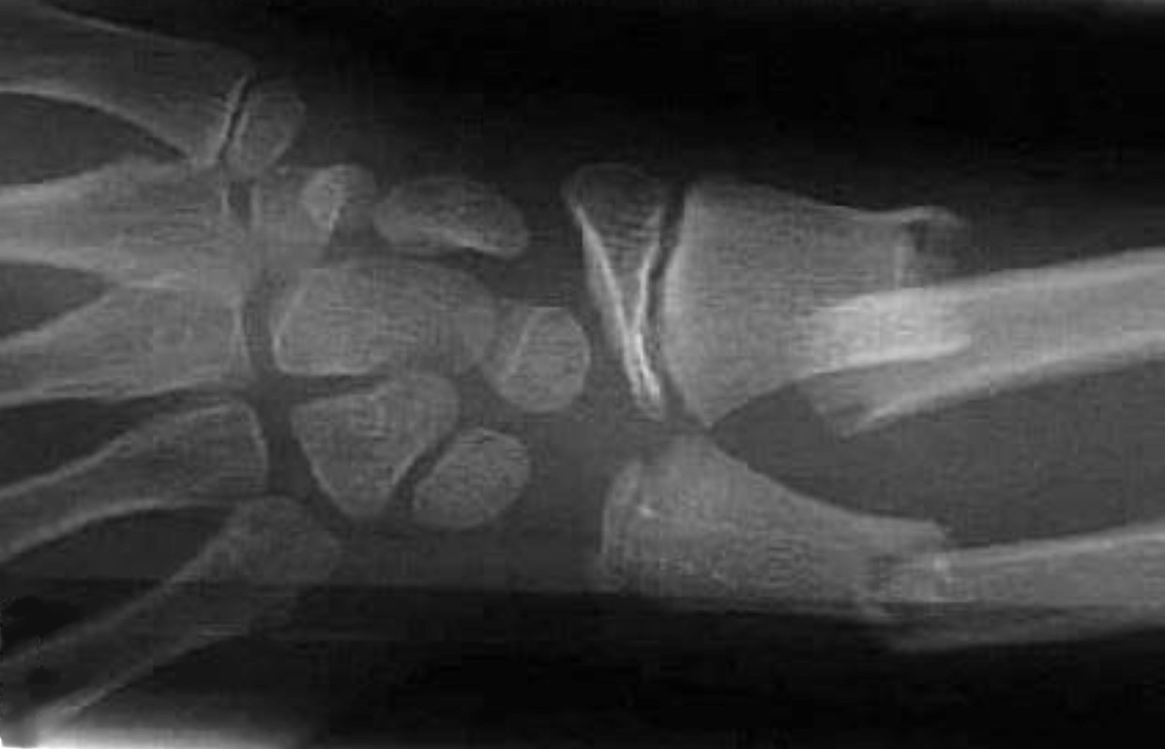
- gather secondary information to observe internal organs from images produced by an endoscope (C3) | - Identify the medical imaging device that would be most useful in viewing a person’s large intestine in real colour and in real time.  - Identify the imaging technology that would be used to produce the images shown below.  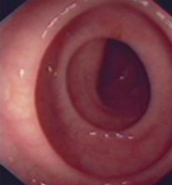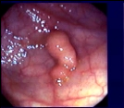
- describe how X-rays are currently produced | - Describe how X-rays are produced.  - Outline two processes by which X-rays are produced.  - Explain the need for the large potential differences used in an X-ray tube.
- compare the differences between ‘soft’ and ‘hard’ X-rays | - Distinguish between ‘soft’ and ‘hard’ X-rays.  - Compare the photon energies of ‘soft’ and ‘hard’ X-rays.  - Outline how ‘soft’ and ‘hard’ X-rays can be produced.
- explain how a computed axial tomography (CAT) scan is produced | - Explain how a computed axial tomography (CT) scan is produced.  - Compare the production of a CT image with the production of a standard radiograph (X-ray image)  - Compare the image produced of the chest by CT with that produced using a conventional X-ray machine.
- gather secondary information to observe a CAT scan image and compare the information provided by CAT scans to that provided by an X-ray image for the same body part (C3) | - A radiographer made a CT scan and a normal X-ray (radiograph) of a patient’s chest for a doctor. Compare the information provided by these two types of images.
- describe circumstances where a CAT scan would be a superior diagnostic tool compared to either X-rays or ultrasound | - Describe circumstances where a CAT scan would be a superior diagnostic tool compared to either X-rays or ultrasound.  - A doctor wanted to accurately locate the position of a tumour in a patient’s lung prior to surgery. Assess the value of a conventional chest X-ray image in achieving this outcome.
- perform a first-hand investigation to demonstrate the transfer of light by optical fibres (C3) | - Recount a first-hand investigation that you carried out to demonstrate the transfer of light by an optical fibre.
- explain how an endoscope works in relation to total internal reflection | - Use a diagram to outline the phenomenon of total internal reflection in an optical fibre.  - Explain the transmission of light through a fibre in an endoscope.
- discuss differences between the role of coherent and incoherent bundles of fibres in an endoscope | - Outline the role of non-coherent fibres in an endoscope.  - Outline the role of coherent fibres in an endoscope.  - Explain how the integrity of an image is maintained from one end of an optical fibre bundle to the other.  - The distal end of a fibre optic bundle in an endoscope has a lens on it. Explain the function of this lens.
- explain how an endoscope is used in:  - observing internal organs  - obtaining tissue samples of internal organs for further testing | - Describe, with reference to the relevant parts of the instrument, how an endoscope is used to examine internal organs.  - Assess the usefulness of an endoscope in obtaining tissue samples.  - Evaluate the use of an endoscope in obtaining tissue samples of internal organs.  - Compare organs and tissues.

Section 9.6.3

3. Radioactivity can be used as a diagnostic tool
- perform an investigation to compare an image of bone scan with an X-ray image (C3)  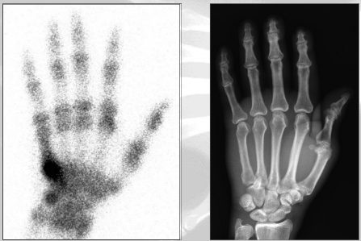 | - Compare the image produced by a bone scan with that produced by a conventional X-ray machine (images shown opposite)  - Describe how the very dark area in the bone scan is produced.  - Outline why the bone scan has poorer resolution of anatomical features than a radiograph.
- outline properties of radioactive isotopes and their half lives that are used to obtain scans of organs  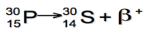 | - Define the term “isotope”.  - Identify the three main types of radioactive decay that radioactive isotopes may undergo.  - Identify two types of radiation produced by radioactive isotopes that are used to obtain scans of organs.  - Phosphorus-30 has a half-life of 2.5 minutes. How much of a 100 g sample of P-30 would remain after 10 minutes? Sketch the decay curve of P-30 and label the half-life.  - Interpret the adjacent equation.  - F-18 is a positron source. Write the decay equation for F-18.
- describe how radioactive isotopes may be metabolised by the body to bind or accumulate in the target organ | - Define the term “metabolism”  - Describe how F-18 is metabolised by the body.  - Account for the accumulation of different isotopes in specific organs of the body.
- gather and process secondary information to compare a scanned image of at least one healthy body part or organ with a scanned image of its diseased counterpart (C3) | - Compare the pairs of images below.  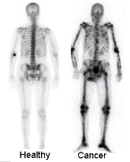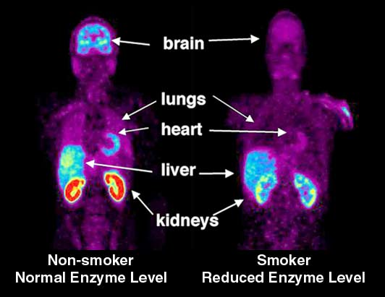
- identify that during decay of specific radioactive nuclei positrons are given off | - Identify the missing particle in the following nuclear decay.  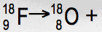  - Describe the characteristic of the F-18 nucleus that results in this decay process.
- discuss (sic) the interaction of electrons and positrons resulting in the production of gamma rays | - Describe the production of gamma rays used in a PET scan.
- describe how the positron emission tomography (PET) technique is used for diagnosis | - Identify the process illustrated below and describe how it can be used for diagnosis.  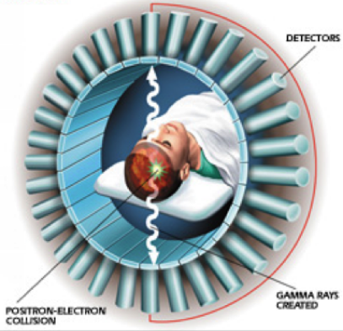  - Contrast a PET scan and a CT scan.  - Assess the benefits of using a PET scan to diagnose brain function disorders.  - Compare a bone scan and a PET scan.  - An understanding of the properties of electrons, and our ability to control their behaviour, have played key roles in the development of CAT scans and PET imaging technologies. Justify this statement with reference to the production and display of images used for medical diagnosis.  - A football player suffers a fractured skull in a game and the fracture was diagnosed using a normal X-ray. It is feared by doctors that some brain function may have also been affected. Suggest a scanning technology that would be useful in diagnosing such damage and justify your choice.

Section 9.6.4

4. The magnetic field produced by nuclear particles can be used as a diagnostic tool
- perform an investigation to observe images from magnetic resonance image (MRI) scans, including a comparison of healthy and damaged tissue (C3) | - Compare the following brain images.  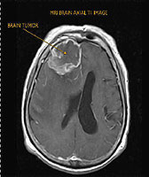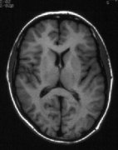
- identify that the nuclei of certain atoms and molecules behave as small magnets | - Identify the property of the hydrogen nucleus that makes it useful for medical imaging.  - Account for the effect that a strong magnetic field has on hydrogen nuclei.
- identify that protons and neutrons in the nucleus have properties of spin and describe how net spin is obtained | - Account for the fact that helium (as opposed to hydrogen) is not used for magnetic resonance imaging of the human body.
- explain that the behaviour of nuclei with a net spin, particularly hydrogen, is related to the magnetic field they produce | - Explain how the spin of a nucleon produces a magnetic field.  - Compare the production of a magnetic field by the hydrogen nucleus to the production of a magnetic field by a coil.
- describe the changes that occur in the orientation of the magnetic axis of nuclei before and after the application of a strong magnetic field | - Describe the effect of applying a strong magnetic field to a material containing hydrogen atoms.
- define precessing (sic) and relate the frequency of the precessing to the composition of the nuclei and the strength of the applied external magnetic field  [correct word is “precession”] | - Define the term precession and outline the significance of the precession of the hydrogen nucleus in the MR imaging process  - Identify the variables that determine the precession frequency of a nucleus in the MR process.
- discuss (sic) the effect of subjecting precessing nuclei to pulses of radio waves | - Describe the effect of subjecting aligned nuclei to a pulse of radio waves.  - Explains the effects of energy transfers and energy transformations that occur in the MRI process.
- gather and process secondary information to identify the function of the electromagnet, radio frequency oscillator, radio receiver and computer in the MRI equipment (C3) | - Identify the function of the electromagnet in an MRI machine.  - Describe the magnetic field used in an MRI machine.  - Identify the function of the RF components in an MRI machine.  - Identify the role played by computers in MR imaging.
- explain that the amplitude of the signal given out when precessing nuclei relax is related to the number of nuclei present | - Outline what is meant by the term “relaxation” in the context of MR imaging.  - Explain the variation in the amplitude of the signal produced by hydrogen nuclei during the relaxation process.
- explain that large differences would occur in the relaxation time between tissue containing hydrogen bound water molecules and tissues containing other molecules | - Account for the relaxation time differences between different tissues.  - Explain why blood and fat can be clearly differentiated using MRI.
- identify data sources, gather, process and present information using available evidence to explain why MRI scans can be used to:  – detect cancerous tissues  – identify areas of high blood flow  – distinguish between grey and white matter in the brain (C3) | - Explain why MRI can be used to detect cancerous tissues.  - Explain why MRI can be used to identify area of high blood flow.  - Explain why MRI can be used to distinguish between white and grey matter in the brain.
- identify data sources, gather and process information to compare the advantages and disadvantages of X-rays, CAT scans, PET scans and MRI scans (C3) | - Use a table to present the advantages and disadvantages of X-rays, CT scans, PET scans and MRI scans.  - Compare the advantages and disadvantages of CT scans and PET scans (4 marks)
- gather, analyse information and use available evidence to assess the impact of medical applications of physics on society (C3) | - Assess the impact of medical applications of physics on society (7 marks)  - Assess the impact of MRI on society. (3 marks)

